**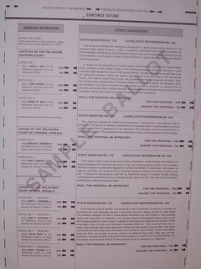Can I bring notes/ Sample ballot to help me, Vote?**

1. You may bring in notes or a sample ballot as a cheat sheet during Voting, but it must leave with you when you are finished.
2. You **CAN NOT** use notes off your cell phone!! No electronics are allowed in the voting room.
3. There is absolutely **NO** sharing notes with anyone next to you while in the voting room, including your Spouse! (ABSOLUTELY NO TALKING)
4. If you will be sharing notes one voter must wait until the other has completed and has exited voting room before passing said notes.